NAME:

Sufyan Ajmal

**BFS without DLS**

* **Definition**: Breadth-First Search explores nodes level by level, starting from the root, and visits all neighbors before moving to the next level.
* **Key Feature**: No depth limit, so it can explore the entire graph/tree until the goal is found or all nodes are visited.
* **Use Case**: Useful when the goal is at an unknown depth, or when we want the shortest path in an unweighted graph

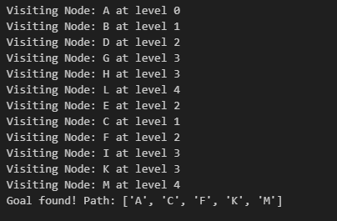

**BFS with DLS**

* **Definition**: Depth-Limited BFS adds a maximum depth (or level) restriction to the normal BFS. It only explores nodes up to a specified depth.
* **Key Feature**: Saves time and memory by avoiding unnecessary deep exploration beyond the given depth.
* **Use Case**: Useful when the goal is expected within a limited depth, or when the search space is very large.

